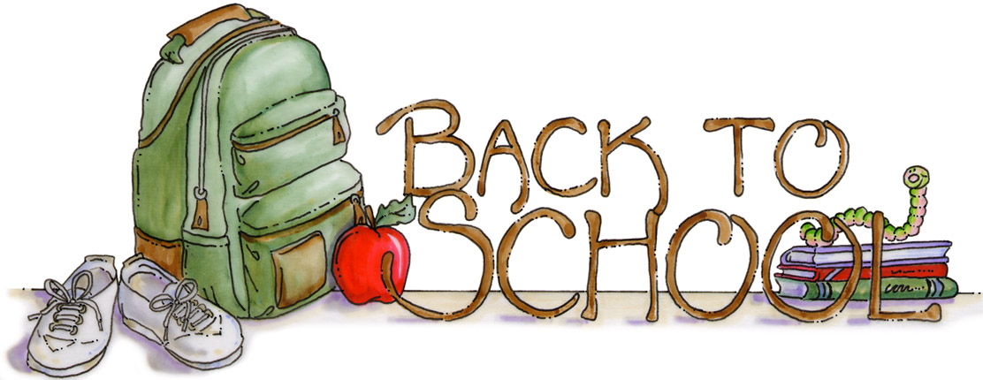

***ONLINE Supply List for 6th Grade***

***at Oasis Elementary 2020-2021***

* Printer
* Disk space on your computer as well as external device to back up your files (flash drive, external hard drive, CD-ROM, etc.)
* Cell phone to take photo of student's work or scanner to scan student's work
* Interactive Notebook (three-ring binder)
* Pencils
* Erasers
* Scissors
* Crayons and colored pencils
* Glue
* Tape
* Ruler
* Printer paper
* Multi-colored paper

**THANK YOU!!!**

C:\Documents and Settings\mthalacker\Local Settings\Temporary Internet Files\Content.IE5\IEHV9AT2\MC900110872[1].wmf

***6th grade is going to be a fantastic year!!!***